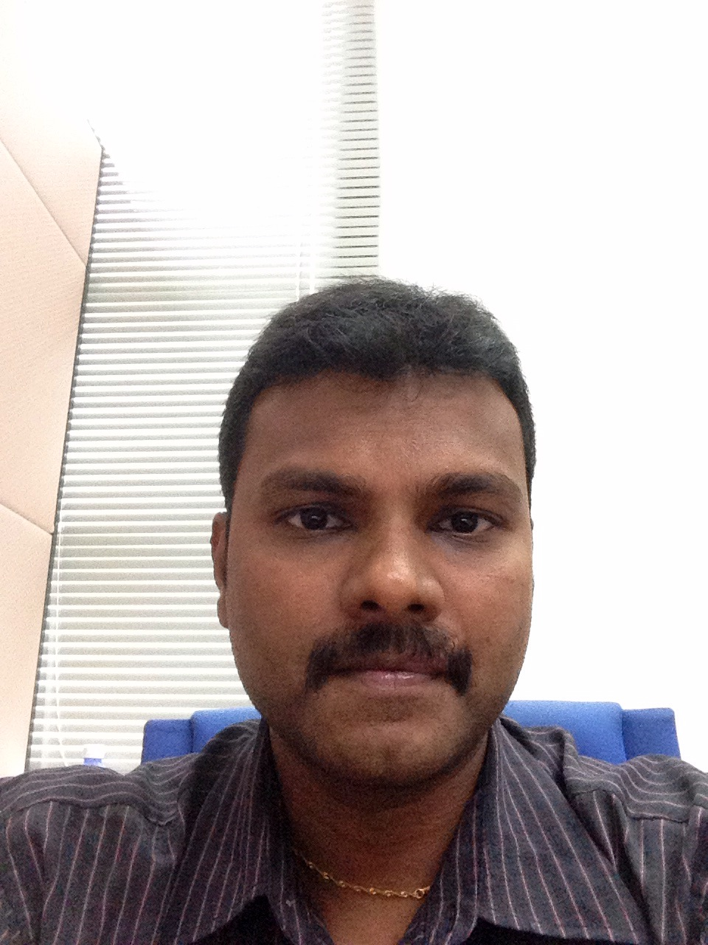

Jayapalan, Elanggovan

Objective: To obtain a challenging position in Manufacturing, warehouse and logistics management where my knowledge, experience and skills will be contributed towards the development of the organization and enhance my management capabilities to the fullest.
Using my skills in management, I’m able contribute to the worldwide success of the company.
Current Address |  |  | Permanent Address
Address | : | Block B-17-7, Sri Jati 2 condominium, No 6 Jalan Sri Jati,off jalan Puchong, 58200 Kuala lumpur | Address | : | Block B-17-7, Sri Jati 2 condominium, No 6 Jalan Sri Jati,off jalan Puchong, 58200 Kuala lumpur
Tel (Home) | : |  | Tel (Home) | :
Tel (Mobile) | : | 6012-6415671
Email | : | elanelan44@gmail.com  elanggovan@ti.com
Personal Particulars
Age | : | 34 years 8 month | Date of Birth | : | 23 Aug 1979
Nationality | : | Malaysia | Gender | : | Male
Marital Status | : | Married | IC No. | : | 790823-02-5591
Educational Background
Highest Education
Level | : | Masters | Grade | : | CGPA - 3.11
Field of Study | : | Business Engineering
Major | : | Management
Name of Institution | : | AEU University
Location | : | Malaysia | Graduation Date | : | 21st April 2013
Second Highest Education
Level | : | Diploma | Grade | : | Grade B/2nd Class Upper
Field of Study | : | Engineering (Electrical/Electronic)
Major | : | Electronics
Name of Institution | : | RIFA
Location | : | Malaysia | Graduation Date | : | June 2000
Employment History
1. | Company Name | : | Texas Instrument Malaysia
 | Position | : | Manager
 | Level | : | Manufacturing Manager
 | Specialization | : | Manufacturing/Warehouse Operations
 | Industry | : | Manufacturing
 | Salary | : | RM 7600
 | Date Joined | : | Nov 2008 | Date Left | : | Present

Work description
I have joined Texas as senior manufacturing executive and in charge of test department, within 7 months In was promoted to team leader which is responsible of managing 3 manufacturing supervisors and approximately 200 operators. Our operation compromises process such as testing IC’s, TSOP chips, QFN chips and other integrated circuits. My main role will be planning and execution of daily operation to ensure all the testers fully optimized, meet customer demands, prioritize devices, fulfill tester capacity and maximize manpower utilization. Upon completing our process, these devices will be sent for reeling (packing). I’m also in charge of inventory management whereby we are using IMS to system to manage inventory. After serving 5 months on this role, I was promoted to manufacturing manager. Here my role expands to cover 3 shifts and with same job scope and there was 8 manufacturing supervisor under my supervision. Basically I’m in charge for Overall device testing process until reeled and shipment. Quality was my top KPI and it goes down to productivity, NPI lots prioritization, DL and IDL turn over, PNL of the department, Scarp reduction, Rescreen reduction, Inventory control, cycle count execution and meeting customer demand.
Responsibilities
1. Develop business and supply chain understanding with different accomplishments in Manufacturing, logistics, sales, and business analysis.
2. Interact effectively with subordinates and internal groups on processes, procedures and company’s policy
3. To maximize the utilization of manpower, material and machinery with minimal machine breakdown and continuous process improvement aligned with Supply Chain strategy
4. Decision on the DL hiring and department expenses. Costing execution of the department.
5. Responsible for preparing daily reports, selecting tools and procedures for production planning, inventory management and replenishment.
6. Provide guidance and support for production and initiate follow-up actions.
7. Also responsible for planning, forecasting, scheduling, and the replenishment
8. Manage people which include manpower planning, overtime control, shift pattern, review workers competency and train staffs in accordance to Company standard training modules
9. Ensure Key Performance Indicator (KPI) targets are continuously met Quality, Cost, Safety and Ethics. Ensure consistency in good housekeeping practices in the production floor
10. To ensure production volumes are sufficient to cope up with sales demands
11. Also responsible for planning, forecasting, scheduling, and the replenishment.
12. Cultivate good factory 5S and emphasis on cleanliness.
13. Practice good kaizen in order to improve standardized activities and processes and bring continues improvement to the organization.
14. Inventory management and promotes safety

2 | Company Name | : | Flextronics Technology
 | Position | : | Senior Manufacturing Executive
 | Level | : | Senior Executive
 | Specialization | : | Warehouse/Manufacturing Operations
 | Industry | : | Manufacturing
 | Salary | : | RM 3800
 | Date Joined | : | May 2003 | Date Left | : | Nov 2008

Work description
I started my career in mobile phone packing operation – DPY as a Shift Manufacturing Executive where it compromises processes such as Picking, Software Uploading, Labeling, Final Test and Packing. Subsequently upon serving 2 years in the above position I was promoted to a Senior Manufacturing Executive in-charge of overall DPY Operations reporting to the Production Manager. Here I was given the responsibility to manage and control 15 packing lines where 7 Manufacturing Executives and approximately 700 direct consisting of shift leaders and operators reporting to me. In DPY Operations our main activities consist mainly of picking, kitting, testing, labeling, packaging and shipping. Prior to picking planners will transmit production order numbers via BAAN System (Warehouse Management System) which will be applied to print Shop-floor (Pick-List). I was also responsible for Semi Finished Product Store and Mini Material store where we store core phone units, direct/indirect materials. Materials here will be picked and released to packaging lines based on customer’s demand/Shop Floor. Basically we pick, assemble, test and pack in accordance to customer’s specification. Upon completion of all the above processes random QA inspection called OBA (Out of box audit) will be performed based on AQL level set by customer. I also work very closely with planning to maximize machine and manpower utilization in order to either meet or exceed Customer Service Levels. Also have Vast Knowledge in warehousing and material handling techniques.

Responsibilities
1. Execution in all logistics functions including production planning, inventory management, customer service, forecasting, transportation and distribution
2. Interact effectively with subordinates and internal groups on processes, procedures and company’s policy
3. To ensure goods are sent to the correct customer based on demand and arrange transportation with the logistic team.
4. Took effort to improve on-time delivery percentage from 93% to 97%
5. Plan, manage, supervising and train production workers on workflow and system.
6. Enabled customer feedback through various channels to improve the supply chain management
7. Ensure Shipments are based on specification and customers’ requirement.
8. Held meetings and discussions with the operation team to assess their capabilities, strength and resources required to carry out the operations successfully
9. Manage people which include manpower planning, overtime control, shift pattern, review workers competency and train staffs in accordance to Company standard training modules
10. Supervise, motivate and lead Shift Executives and operators to achieve quality targets, production output, yield target and meet delivery schedule
11. Manage and control usage of raw materials and stationery
12. To motivate, counsel, train and lead subordinates to maintain good teamwork and good 5S.
13. Practice lean manufacturing in order to reduce waste and improve overall customer value.

Recognition
I was awarded the Best Quarterly Achiever for exceeding quality, output and on time delivery to the customers. This is a great achievement for me as our management only selected few of us to be awarded from 1500 employee across the plant.

Just completed a business studies in new Zealand and successfully received honored certificate from New Zealand learning and Development centre and Waikato University.

3. | Company Name | : | Smart Modular Technologies
 | Position | : | Supervisor
 | Level | : | Production Executive
 | Specialization | : | Manufacturing/Staging Operations
 | Industry | : | Manufacturing
 | Salary | : | RM 2200
 | Date Joined | : | Oct 1999 | Date Left | : | Apr 2003

Work description
During my 4 years in Smart Modular, I was responsible for 6 SMT lines and System Build. I was accountable for 6 team leaders and approximately 70 production operators. I have an excellent track record in Manufacturing Management and particularly in Surface Mount Technology (PCBA), Integrate Circuit Assembly and System Build - High End Servers. I was stationed in Munich, Germany for 2 years where I was also involved in prototype build and transfer of System Build to Malaysia, USA and Europe region for Force Computers in Germany.

Skills
Skill | Years | Proficiency
Wip Track | 4 | Advanced
SAP and IMS | 8 | Advanced
MS Office/word | 9 | Advanced
Vector | 3 | Advanced
C++ Language | 3 | Intermediate
Flex flow System | 3 | Advanced
Baan / Warehouse Management System | 8 | Advanced
FFDS(flex flow delivery system)  Other skill related to Operations  - Costing/Budgeting  - People devolvement  - KPI definition and execution  - Process improvement  - Working capital optimization  - Global benchmarking  - BPS acceleration  - Production/Operation and Quality management  - Capacity modelling  - Change management  - 5 why analysis, failure mode analysis | 3 | Advanced

Languages
 | Proficiency (Best=10 - Worst=1)
Language | Spoken | Written
English | 9 | 9
Bahasa Malaysia | 9 | 8
Tamil | 9 | 7

Preferences
Willing to Travel | : | Yes
Willing to Relocate | : | Yes
Possess Own Transport | : | Yes
Expected Monthly Salary | : | RM9000 (Negotiable)
Availability | : | 1 month
Miscellaneous
Others | : | Knowledge earned during studies  1) Basic single phase and 3 phase wiring  2) Basic tv,radio and any other electronics device repairing (attend course in this)  3) On how to use multimeter ,rcl meter,ociloscope in both dc and ac current  4) Basic programming in computer(c++,excel,word and etc)  5) Engg. Drawing and basic management studies  During my 9 years of working experience below are the knowledge I have gained  1) Planning and Documentation skills  2) Good management and leadership skills.  3) Good manufacturing practice such as 5S, Benchmarking, material management and others  4) SAP and IMS  5) Excellent communication skill.  6) Familiar with MS Word, MS Excel, MS Power point, & Internet  7) Experienced in solving customer complaints  8) Thorough knowledge of all test, warehouse, packaging and Logistic equipment.  9) Strong background in Manufacturing, warehousing & logistic planning and redeployment activities  Yours truly,  Elanggovan Jayapalan
References
Name | : | Raymond Hong
Telephone | : | 019-3826412
Email | : | Raymond@flextronics.com
Position | : | Senior Manager
Company | : | Flextronics Technology
Name | : | Baskaran Raman
Telephone | : | 012- 6828259
Email | : | Baskaran@sti.com
Position | : | Logistic senior Manager
Company | : | STI micro technologies
Name | : | Paramasivam
Telephone | : | 012- 6413827
Email | : | Paramasivam@ti.com
Position | : | Senior Manufacturing Manager
Company | : | Texas Instruments

